CLINICAL PHARMACOKINETICS EQUATION LIST
VANCOMYCIN AND AMINOGLYCOSIDES

- Ke = 0.00293 (CrCL) + 0.014 (gentamicin, tobramycin, amikacin)

- Ke = 0.00083 (CrCL) + 0.0044 (vancomycin)

- Vd = 0.25 L/kg (gentamicin, tobramycin, amikacin)

- Vd = 0.7 L/kg (vancomycin)

- t_{1/2} = 0.693
Ke

- C₂ = C₁ x e ^{–Ke x t} OR ln (C₁/ C₂) = Ke
t

- CL = Vd x Ke

- LD = C_{max desired} x Vd

- τ = ln (Cmax desired / Cmin desired) + t’ t’ = infusion time (hr)
Ke

10. R_{O} = (Ke) (Vd) (Cmax desired) x (1-e ^{-Ke x T})
(1-e ^{-Ke x t’})

11. C_{peak} = R_{O} x (1-e ^{-Ke x t’}) R_{O} = infusion rate; also the
(Ke)(Vd) (1-e ^{-Ke x T}) maintenance dose, in
milligrams per hour

12. C_{trough} = C_{peak} x (e ^{–Ke (T – t’)})

13. Vd = R_{O} x (1 – e ^{–Ke x t’})
Ke (C_{extrap. peak} – C_{extrap. trough})

Hartford Nomogram:
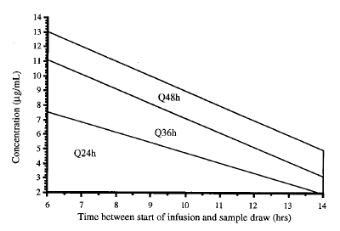

Initial dosing interval using the Hartford nomogram

CREATININE CLEARANCE (mL/min) | DOSING INTERVAL (hr)
> 60 | 24
40-59 | 36
20-39 | 48
<20 | Dose when concentration is < 1-2 mcg/mL

CALCULATION OF AMINOGLYCOSIDE DOSING IN HD

Step 1: Estimate Volume of Distribution (population-parameters)

V_{D} = 0.25L/kg

OR calculate the patient-specific V_{D} if loading dose and C_{peak} are given

V_{D} = C_{peak}
L_{D}

Step 2: If a loading dose is given – estimate C_{peak} using V_{D}

C_{peak} = LD/V_{D}

OR calculate a loading dose using V_{D} and C_{peak desired}

LD = C_{peak} _{X} V_{D}

Step 3: Estimate pre-dialysis concentration, using the time until the next HD session and Ke (off HD)
Ke off = 0.021/hr (population parameter)

C_{pre-HD =} C_{peak} _{X} e^{-ke off x t}

Step 4: Estimate post-dialysis concentration using Ke (on HD) and time (duration of dialysis)
Ke on = 0.178/hr (population parameter)

C_{post-HD =} C_{pre-HD} _{X} e^{-ke on x t}

Step 5: Calculate supplemental dose using the post-HD concentration, desired peak and V_{D}

Dose = V_{D} _{X} (C_{desired –} C_{post-HD})

